**KUBERNETES COMPLETE**

* Kubernetes is an open source container orchestration engine for automating deployment, scaling, and management of containerized applications.
* A Kubernetes cluster consists of a set of worker machines, called nodes, that run containerized applications. Every cluster has at least one worker node.

**POD:**

* A Pod is the basic execution unit of a Kubernetes application--the smallest and simplest unit in the Kubernetes object model that you create or deploy.
* **Each POD many have multiple containers. But “one-container-per-Pod” is recommended.
* Each Pod is meant to run a single instance of a given application.
* Pods provide two kinds of shared resources for their constituent containers: networking and storage.
* Each Pod is assigned a unique IP address. Every container in a Pod shares the network namespace, including the IP address and network ports.
* A Pod can specify a set of shared storage volumes. All containers in the Pod can access the shared volumes, allowing those containers to share data.
* A Pod is not a process, but an environment for running a container. A Pod persists until it is deleted.

**Terminology and Controllers:**

* **ReplicaSet:** the default, is a relatively simple type. It ensures the specified number of pods are running
* **Deployment:** is a declarative way of managing pods via ReplicaSets. Includes rollback and rolling update mechanisms
* **Daemonset:** is a way of ensuring each node will run an instance of a pod. Used for cluster services, like health monitoring and log forwarding
* **StatefulSet:** is tailored to managing pods that must persist or maintain state
* **Job and CronJob:** run short-lived jobs as a one-off or on a schedule.

**NODES:**

A node is a worker machine in Kubernetes, previously known as a minion.A node may be a VM or physical machine.

Each node contains the services necessary to run pods and is managed by the master components. The services on a node include the container runtime, kubelet and kube-proxy. Node is externally created by cloud providers.

**Kubernetes node Components interface:**

**Node controller:** is a Kubernetes master component which manages various aspects of nodes like Node status, Node health, assign cidr block to node.

**Kubelet:** An agent that runs on each node in the cluster. It makes sure that containers are running in a Pod.

**kube-proxy:** kube-proxy is a network proxy that runs on each node in your cluster. kube-proxy maintains network rules on nodes.

**Container Runtime:** The container runtime is the software that is responsible for running containers.

**\*\*\*Heartbeats, sent by Kubernetes nodes, help determine the availability of a node.**

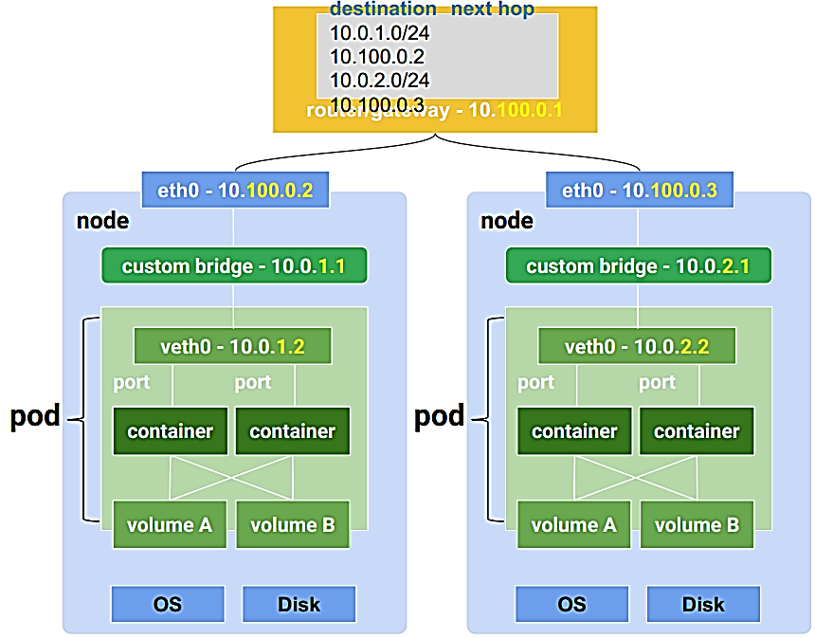

**Cluster:**

A cluster is a set of computers working as an instance managed by Kubernetes. You can have up to 5,000 nodes in a cluster. Regional clusters have masters and nodes spread across 3 zones for high availability and resilience from single zone failure and downtime during master upgrades.

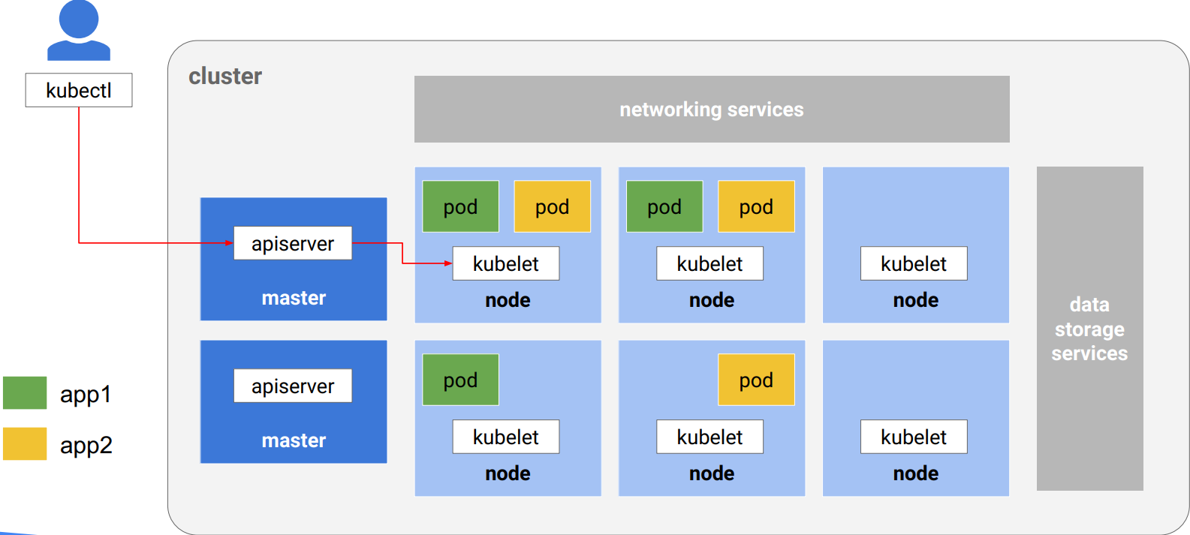

**CLUSTER >>> NODE >>> POD**

**CLUSTER = NODES + MASTER**

**NODE = PODS + Containers**

**POD = Containers**

**Labels**:

Labels are arbitrary metadata you can attach to any object in the Kubernetes API. Labels tell you how to group these things to get an identity. This is the only way you can group things in Kubernetes.

EX: 4pods 3 Labels labels APP: MYAPP; Phase: test/prod; Role: Front End/ Back End/

**Volumes:**

Volumes are a way for containers within a pod to share data, and they allow for Pods to be stateful. These are two very important concerns for production applications.

There are many different types of volumes in Kubernetes. Some of the volume types include long-lived persistent volumes, temporary, short-lived

**NOTE:** Kubernetes *persistent volumes* are administrator provisioned volumes. These are created with a particular filesystem, size, and identifying characteristics such as volume IDs and names.

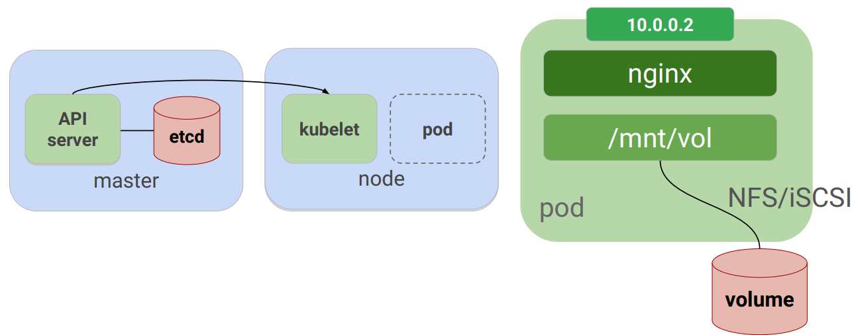

<https://kubernetes.io/docs/concepts/storage/volumes/>

**Different Volumes:**

1. **LOCAL:** A local volume represents a mounted local storage disk or Dir. Used only for static provision of persistent volume. More durable than Host-path.
2. **AWS ELASTICBLOCKSTORE:** Mounts an Amazon Web Services (AWS) EBS Volume into your Pod. Nodes on which Pods are running must be AWS EC2 instances. Instances need to be in the same region and availability-zone.
3. **NFS (NETWORK FILE SYSTEM):** NFS volume allows an existing NFS (Network File System) share to be mounted into your Pod.
4. **CONFIGMAP:** The configMap resource provides a way to inject configuration data into Pods. The data stored in a ConfigMap object. You must create a ConfigMap before you can use it.
5. **FLOCKER:** Flocker is an open-source clustered Container data volume manager. A flocker volume allows a Flocker dataset to be mounted into a Pod.
6. **GCEPERSISTENTDISK:** A gcePersistentDisk volume mounts a Google Compute Engine (GCE) Persistent Disk into your Pod. You must create a PD using gcloud before you can use it.
7. **PERSISTENTVOLUMECLAIM:** A persistentVolumeClaim volume is used to mount a PersistentVolume into a Pod. User dont need to know where they are created.

**Kubernetes - Cluster Architecture:**

**Kubernetes - Master Machine Components:**

1. **ETCD:** It stores the configuration information which can be used by each of the nodes in the cluster. It is a distributed key value Store which is accessible to all.
2. **API SERVER(MAIN):** The Kubernetes API server validates and configures data for the api objects which include pods, services, replicationcontrollers, and others. It helps in communication of pods by using kubectl
3. 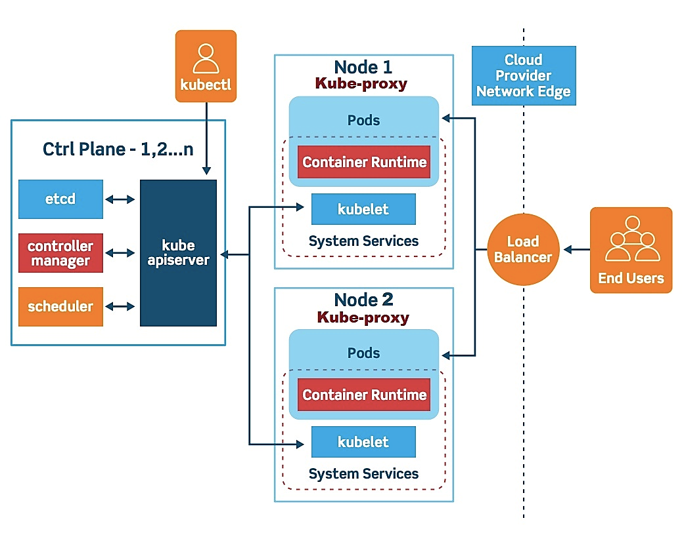**CONTROLLER MANAGER:** It is responsible for maintaining desired states mentioned in the manifest.
4. **SCHEDULER:** It watches for new work tasks and assigns them to healthy nodes in the cluster. The scheduler is responsible for workload utilization and allocating pod to new node.

* Pods.yml ----> To create only pods
* ReplicationController ---> To create replication on pods
* Service ---> To expose Node port or for Load Balance
* ReplicaSet ---> To create pods or versioning or rolling updates without downtime. Used in Deployment

**Kubernetes Options for Installation**

1. **Bare-Metal Installations:**

Start from OS Install Every Component K8s the hard way Other Managed Installations:

2. **Popular options**

1. MINIKUBE (DEVELOPER)
2. MICRO K8S (DEVELOPER)
3. KUBE-ADMIN
4. KOPS

3. **Cloud-Provider Installations:**

GKE AKS EKS

**HEAPSTER** is a performance monitoring, metrics collection system, and aslo allows events and signal generated by cluster compatible with Kubernetes versions 1.0. 6 and above

**MINIKUBE** is a tool that makes it easy to run Kubernetes locally. Minikube runs a single-node Kubernetes cluster inside a Virtual Machine (VM) on your laptop for users looking to try out Kubernetes or develop with it day-to-day.

**KUBELET:** is an agent service which runs on each node and enables the slave to communicate with master. So Kubelet works on the description of containers provided to it in the podspec and make sure that the containers describe in the PodSpec are healthy and running.

**KUBECTL** is the platform using which you can pass commands to the cluster. SO it basically provide the cli to run commands against the kubernetes cluster with various ways to create and manage the kubernetes components.

**KUBEPROXY:** It runs on each node and can do simple TCP/UDP packet forwarding across backend network service.

**REPLICA SET VS REPLICATION CONTROLLER**

* Replica Set manifest works on "Set based Selector" Which means it will use matchLabels and matchExpression to replicate the pods.

Ex: matchLabels: env in (prod, qa); matchExpression: tier notin (frontend, backend)

* Replication Controller manifest works on "Equity based Selector" Which means If the label name matches then only it creates replica for that label-selectors.

EX: APP = Ngnix; env = prod ; tier != frontend

**KUBECTL DRAIN:** command is used to drain a specific node during maintenance. Once this command is given, the node goes for maintenance and is made unavailable to any user.

**API versions:**

**Alpha level:(for example, v1alpha1).** prone to errors but the user can drop for support to rectify errors at any time.

**Beta level:(for example, v2beta3).** Scripts present in this version will be firm since because they are completely tested

**Stable level:(vX X is integer)** Stable level versions get many updates often

**RECREATE AND ROLLING UPDATEDEPLOYMENT STRATEGY:**

* **Recreate** is used to kill all the running (existing) replication controllers and creates newer replication controllers. Recreate helps the user in faster deployment whereas it increases the downtime.
* **Rolling update** also helps the user to replace the existing replica controller to newer ones. But, the deployment time is slow and in fact, we could say, there is no deployment at all
* Create deployment:

**KUBERNETES NAME SPACE:**

* Namespaces are given to provide an identity to the user to differentiate them from the other users. Namespace assigned to a user must be unique
* Namespaces assist information exchange between pod to pod through the same namespace. Namespaces are a way to divide cluster resources between multiple users.
* Kubernetes starts with three initial namespaces:

**DEFAULT**: The default namespace for objects with no other namespace

**KUBE-SYSTEM**: The namespace for objects created by the Kubernetes system

**KUBE-PUBLIC:** This namespace is created automatically and is readable by all users

**KUBERNETES LOAD BALANCING:**

**Internal load balancing:** used to balance the loads automatically and allocates the pods within the necessary configuration

**External load balancing:** It transfers or drags the entire traffic from the external loads to backend pods.